# Remote Sensing 2020 Installation Guide

In the following Guide you will find all the software products needed for the Class of Remote Sensing for the Summersemester 2020.

If you are using a Linux based operating system (Mac OS for example) most software products might not be available for you.

However the main focus of the practice lies on using **QGIS** and **Conda**, these products are also available for Linux based systems, so make sure to at least install those two products.

When installing ArGis and ERDAS Imagine make sure you have a working internet connection since the licencing processes need to connect to the companies servers.

Contents

Remote Sensing 2020 Installation Guide 1

How to find out if your Windows installation is 32 or 64-bit 2

How to Install IrfanView 2

How to Install ArcGis Pro for Desktop (Arcmap) 3

How to Install ERDAS Imagine 2018 11

How to Install Qgis 14

How to Install Conda 15

## How to find out if your Windows installation is 32 or 64-bit

See this step by step tutorial

(<https://www.computerhope.com/issues/ch001121.htm>)

## How to Install IrfanView

Go to

<https://www.irfanview.de/>

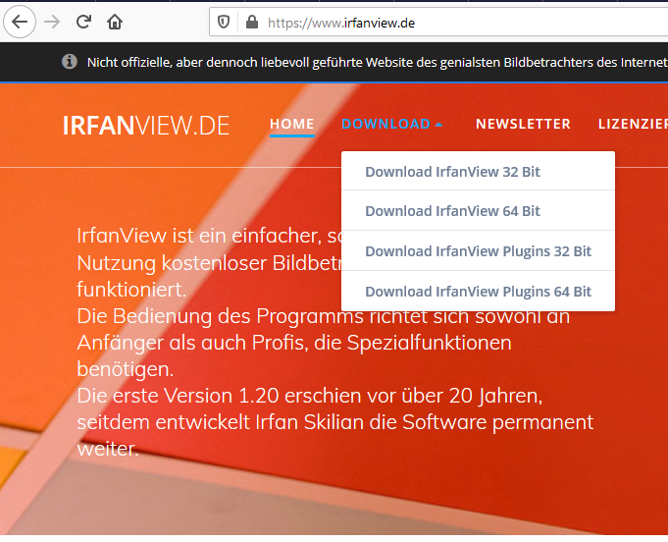

Choose IrfanView 32 or 64 bit according to your system configuration.

## How to Install ArcGis Pro for Desktop (Arcmap)

German Tutorial with Video instructions:

<https://gis-iq.esri.de/arcgis-fuer-studierende-jahreslizenz-installieren/>

In order to install this software you will need an Esri Account.

In case you don’t have one yet, you can create it by following the link on this site:

<https://www.esri.com/en-us/arcgis/products/arcgis-desktop-student-trial>

After registering your information, you will be sent a confirmation link to your email to verify it.

After clicking it, you’re good to go and you can return to the site and click on “I have an Esri Acocunt”.

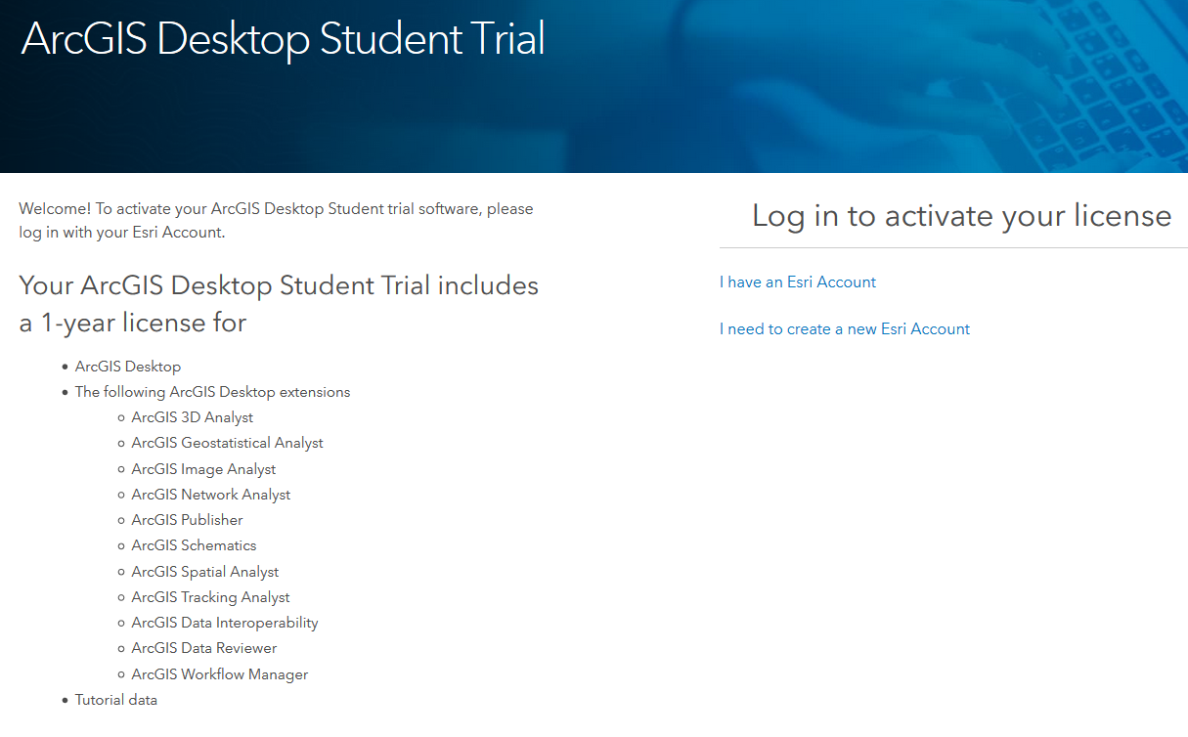

<https://www.esri.com/en-us/arcgis/products/arcgis-desktop-student-trial>

After Registering/loging in you will be redirected to a site where you can choose your ArcGis Versions. You should go with the newest one on the upper left.

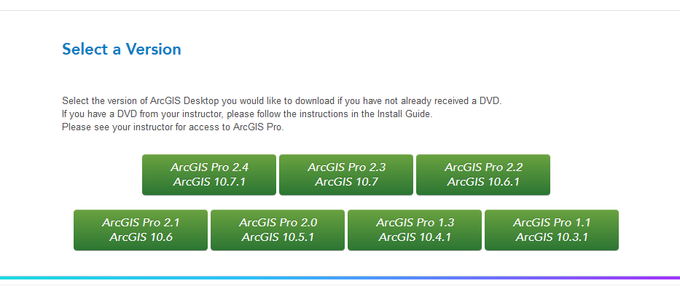

A site with installation instructions and the following Download options will appear.

Follow the installation Steps by making Sure to have Microsoft .NET Framework 3.5 Service pack 1

and 4.5 installed by downloading and executing both installers.

If this is the case, the version 3.5 installer will close itself upon opening

The installer will inform you and you can close the installer yourself.

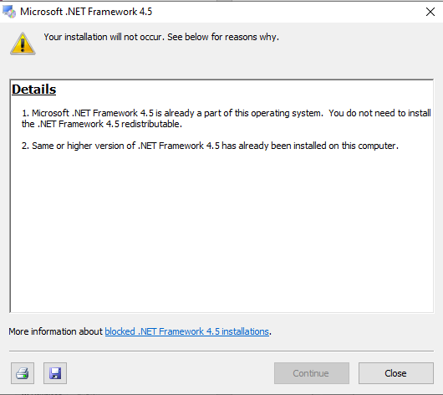

Now that all the requisites are covered you can select the desired software, we will need “ArcGIS Desktop (ArcMap)” for this course.

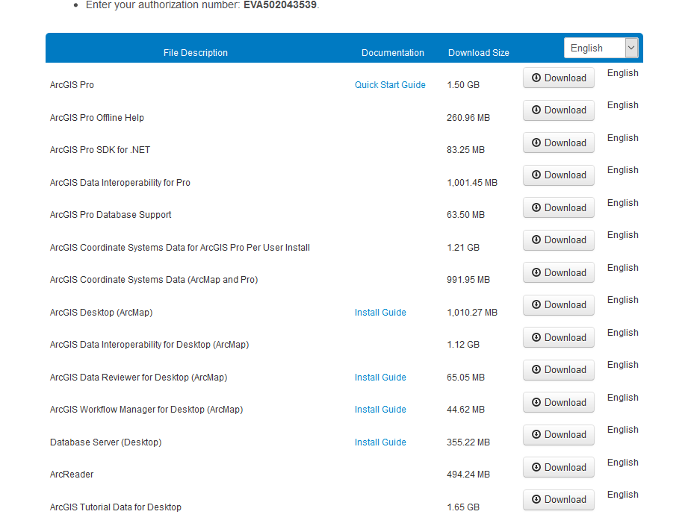

Download the file, execute it and install the software with the configuration offered by the installation routine. Feel free to change the installation directory if you wish.

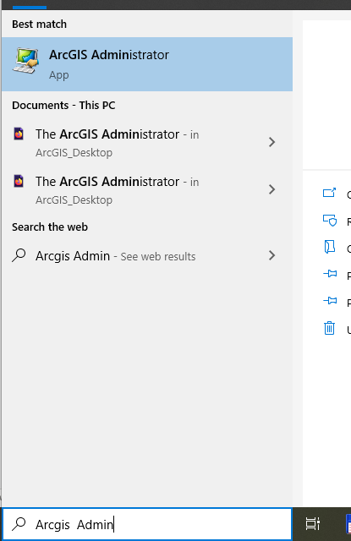

After installing the downloaded file open the “ArcGIS” Administrator software.

Click on “Desktop” in the left part of the Window.

Select Advanced (ArcInfo) Single Use (if you are given the option) and click on the “Authorize Now…” Button

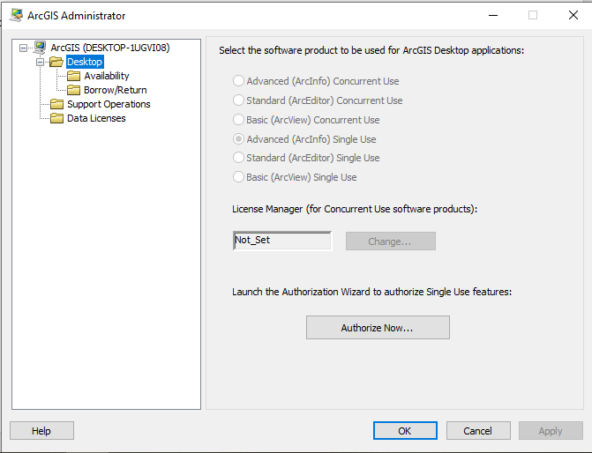

A window titled “Software Authorization Wizard” will pop up, the following option and click next.

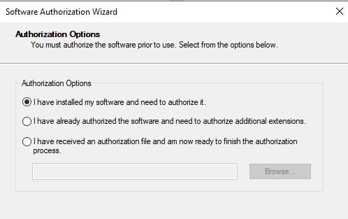

Now select the Internet Authorization and click Next.

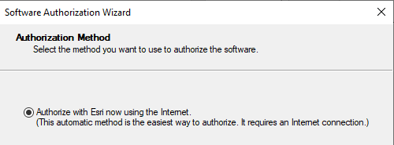

Afterwards the Client will show a Window to enter the Information paired to your licence Key.

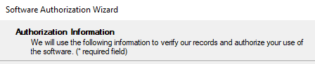

Enter your information here and click Next.

Afterwards you will be asked to Enter the Licence Code sent to you by Email.

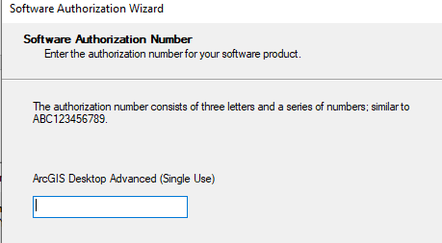

Enter or copy it and hit Next.

In this window you should not authorize any Software Extension and hit Next

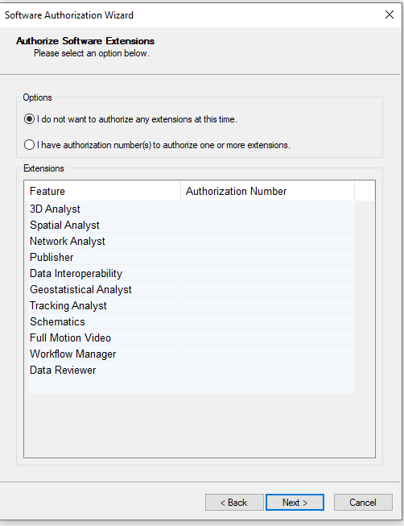

In the following Window you will have to hit Next without selecting any of the Extensions on the left side.

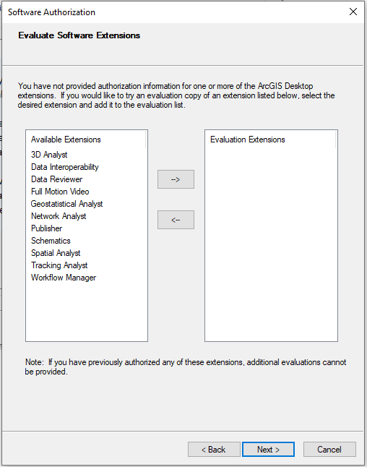

The Software will now automatically authorize all available packages automatically.

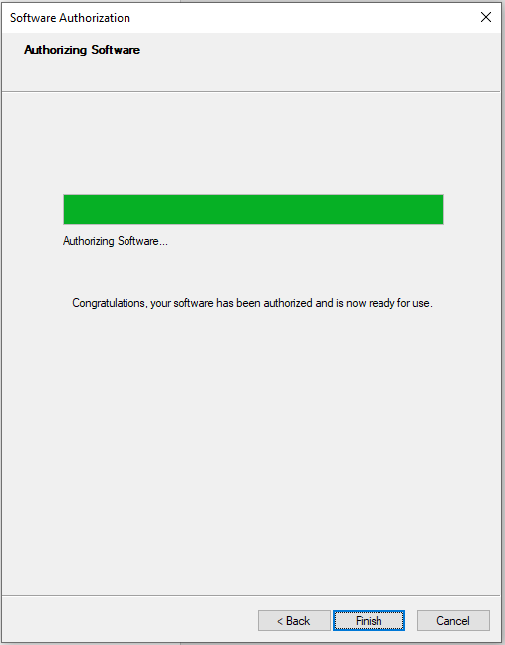

## How to Install ERDAS Imagine 2018

You can download the software here

<https://download.hexagongeospatial.com/downloads/imagine/erdas-imagine-2018?result=true>

On the bottom of the site you can register your information.

Afterwards the site will reload and a download button will appear on the bottom of the page.

After dowloading extract it to a folder and execute “Setup.exe”by doubleclicking it.

In the window above select Erdas Imagine and click on install.

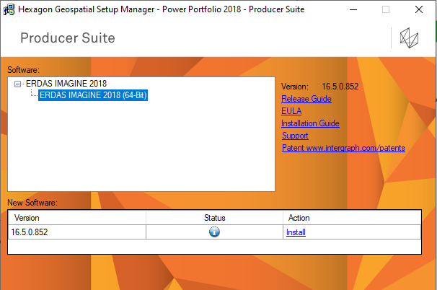

Make sure ERDAS IMAGINE formats and project formats are selected.

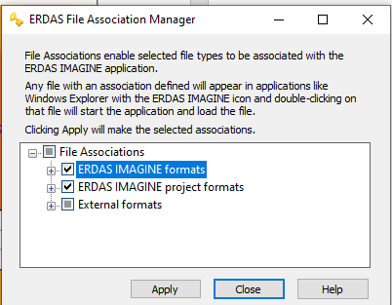

This Small Window will open.

Make sure ERDAS IMAGINE formats and project formats are selected.

Press “Apply” and then press “Close”

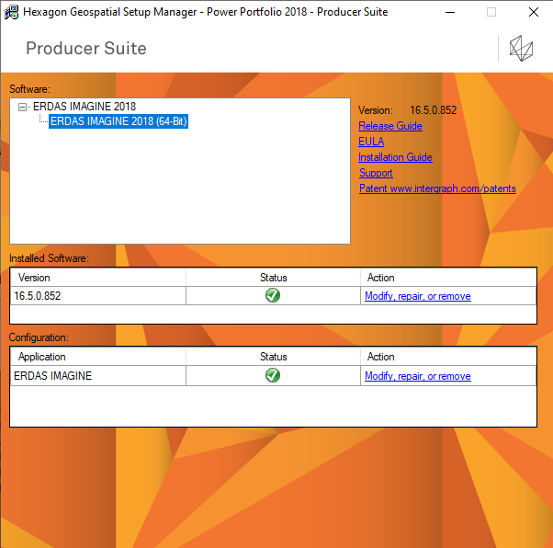

Afterwards the installation other installation windows might open, the installation will run automatically.

After the installation and configuration processes have all finished the installation window should look like this.

It can now be closed.

You can now open ERDAS Imagine, a licence will pop up.

Press ok and the Licence Activation will open automatically.

The activation Window should look like this:

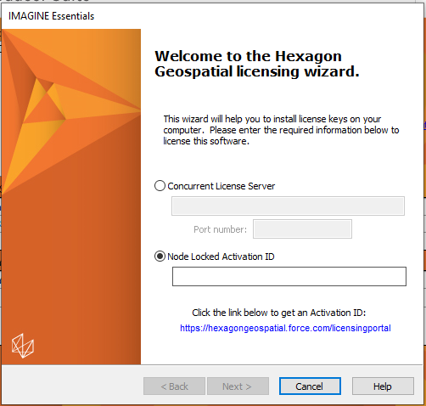

Select “Node Locked Activation ID”, enter your registration Code and click Next.

The software will be licensed and should open itself when this is finished.

It is ready to use!

## How to Install Qgis

Download Qgis according to your System Configuration (32/64-bit and operating system):

<https://www.qgis.org/en/site/forusers/download.html>

You can either use the standalone installer, which includes all the data needed for installation, or a network installer which takes care of downloading and installing the software.

There is also the choice between the newest release and the long term release, both should be fine for our practice.

Since the software is open source the software is able to run after executing the installer without further licensing issues.

For Windows users:

Choose QGIS 32 or 64 bit according to your system configuration.

(<https://www.computerhope.com/issues/ch001121.htm>)

## How to Install Conda

**What‘s Conda?**

*„Conda is an open-source package management system and environment management system that runs on Windows, macOS, and Linux. Conda quickly installs, runs, and updates packages and their dependencies. Conda easily creates, saves, loads, and switches between environments on your local computer. It was created for Python programs but it can package and distribute software for any language.“* (https://docs.conda.io/projects/conda/en/latest/)

In this course Conda is used to manage the software needed to execute python scripts.

The fundamental advantage of using Conda is that it can manage software written in different programming languages. This is useful when integrating libraries written in more performant languages like C into more user-friendly languages like python.

For this course it will be enough to install the command line version of Conda (called Miniconda), a User Interface version is also available.

Make sure to get the correct version with **Python 3.7** according to your system specifications.

The latest version of Miniconda can be downloaded here:

<https://docs.conda.io/en/latest/miniconda.html>

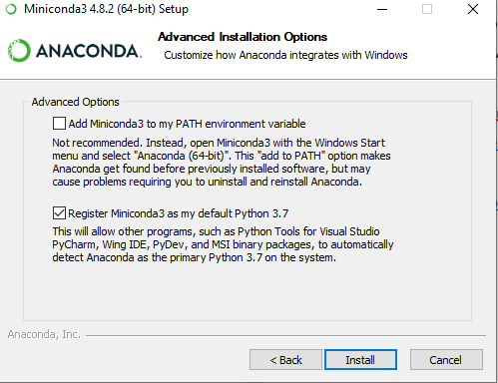

Windows Users will just have to execute the downloaded “.exe” file. When installing under Windows the following window will pop up. If you are already using Python on your computer, make sure none of the advanced options are selected as these might interfere with your current installation and they are not needed for this project.

For mac users follow this guide:

<https://docs.conda.io/projects/conda/en/latest/user-guide/install/macos.html>